**Work artifacts:**

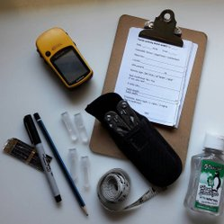

Leatherman, handheld GPS, tape measure, hand sanitizer, pencil, marker, test vials, clipboard/documentation notes

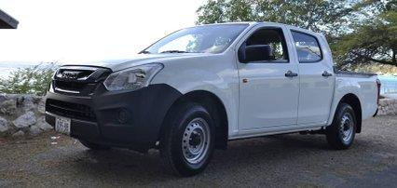

Truck for volunteer transport to nests

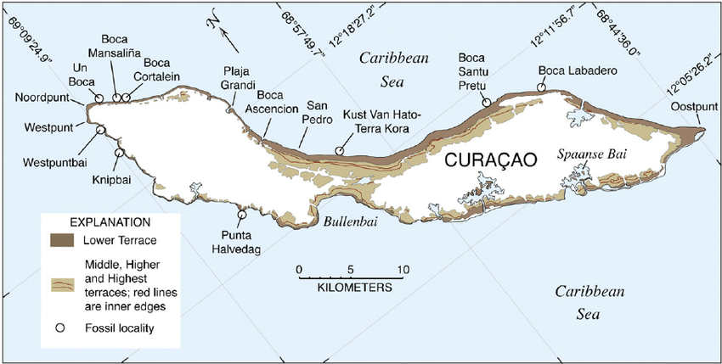

Lots of maps (lat/long)